**Experiment No. 6: Electronic Voltmeter**

Name: Mansi Uniyal

Roll no.: 19EE10039

Date: 8 March 2021

**Objective:**

To construct Electronic Voltmeters for small A.C. and D.C. voltage measurements and study their performances.

**Theory:**

1. **D.C. Voltmeter:**

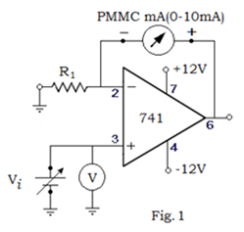

1. **A.C. Voltmeter:**

$I_{av}=\frac{V_{m}}{πR_{1}}$

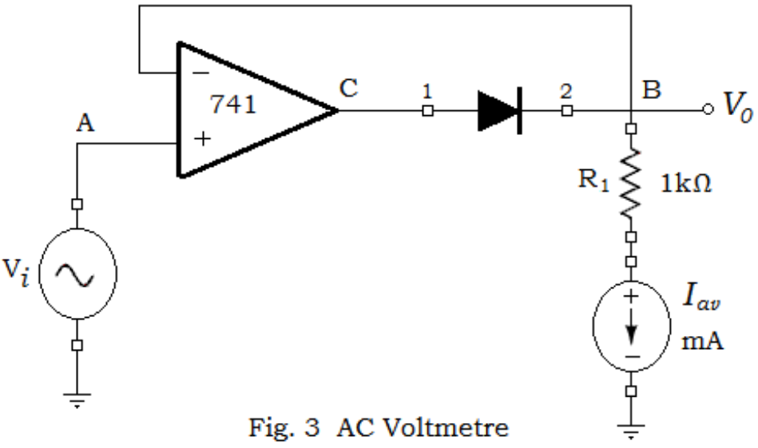

1. **Improved A.C. Rectification Scheme:**

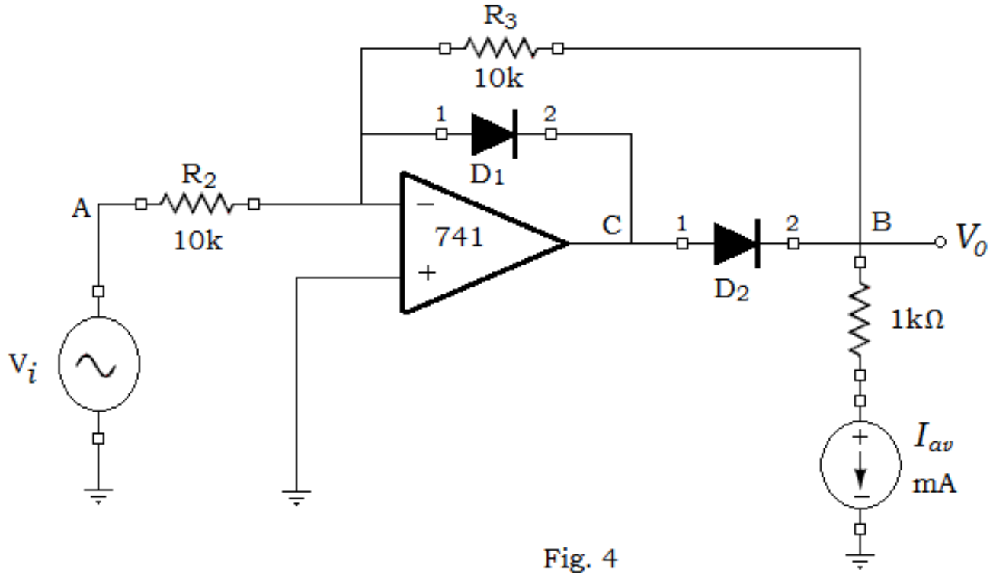

**Simulation Assignment:**

1. Draw neatly the above circuit shown in Fig. 1 in LTSpice. All the components should be chosen as ideal. Attach the screen-shot of the schematic.  
   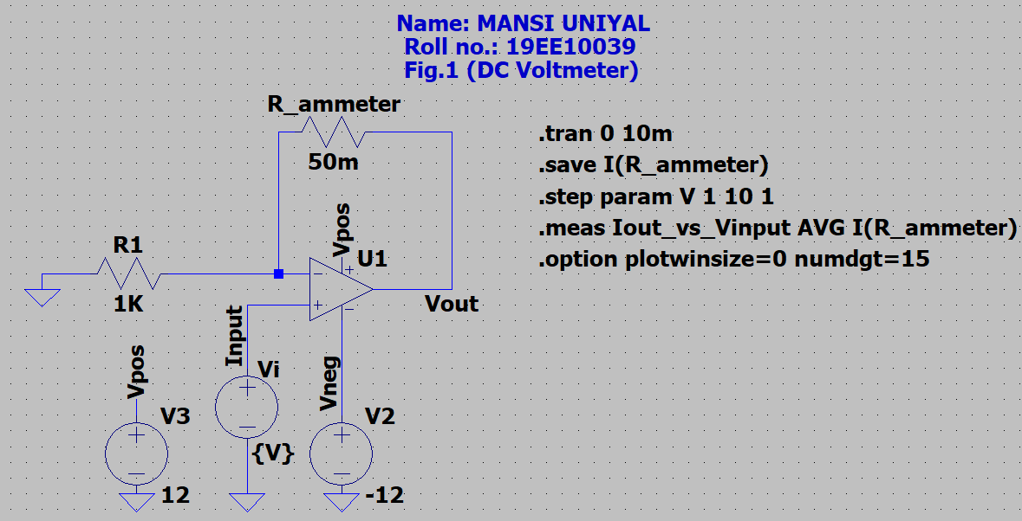

Assume the maximum current can be measured by the milliammeter in Fig. 1, which is 10 mA. The milliammeter is replaced by an equivalent 50 mΩ resistance (Rammeter).

* 1. Simulate the circuit for R1 = 1 kΩ. Vary the input voltage Vi in the range of 0 – 10 V D.C. with a step of 1 V. Note the current I through the resistance Rammeter. Attach the screenshot of the current, and plot I vs. Vi.

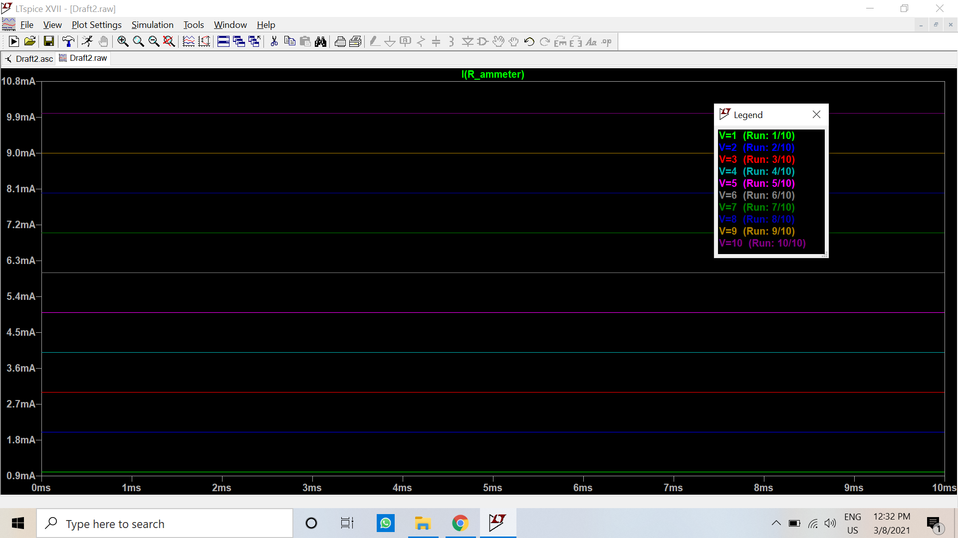

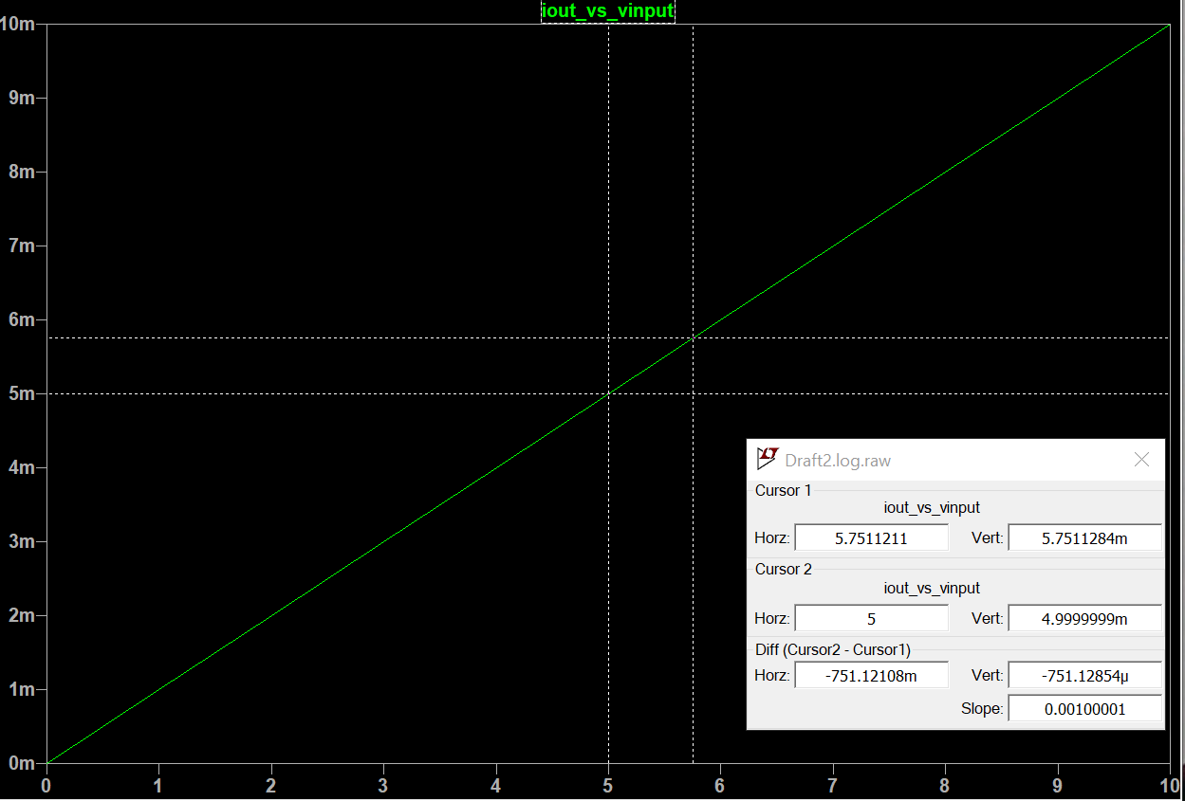

* 1. Change R1 to 100 Ω. Vary the voltage Vi in the range of 0 – 1 V D.C. with a step of 0.1 V. Repeat the step-i.

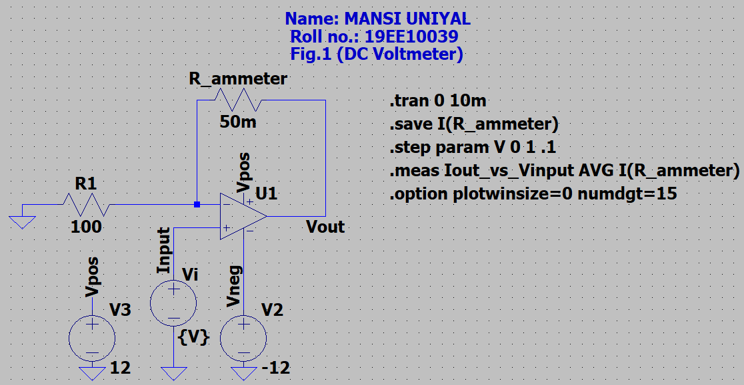

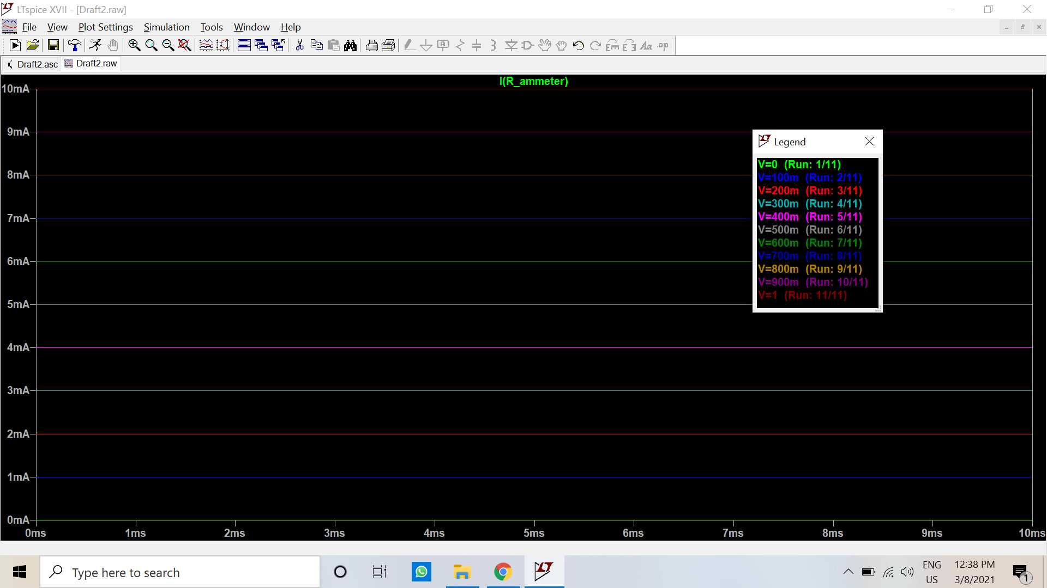

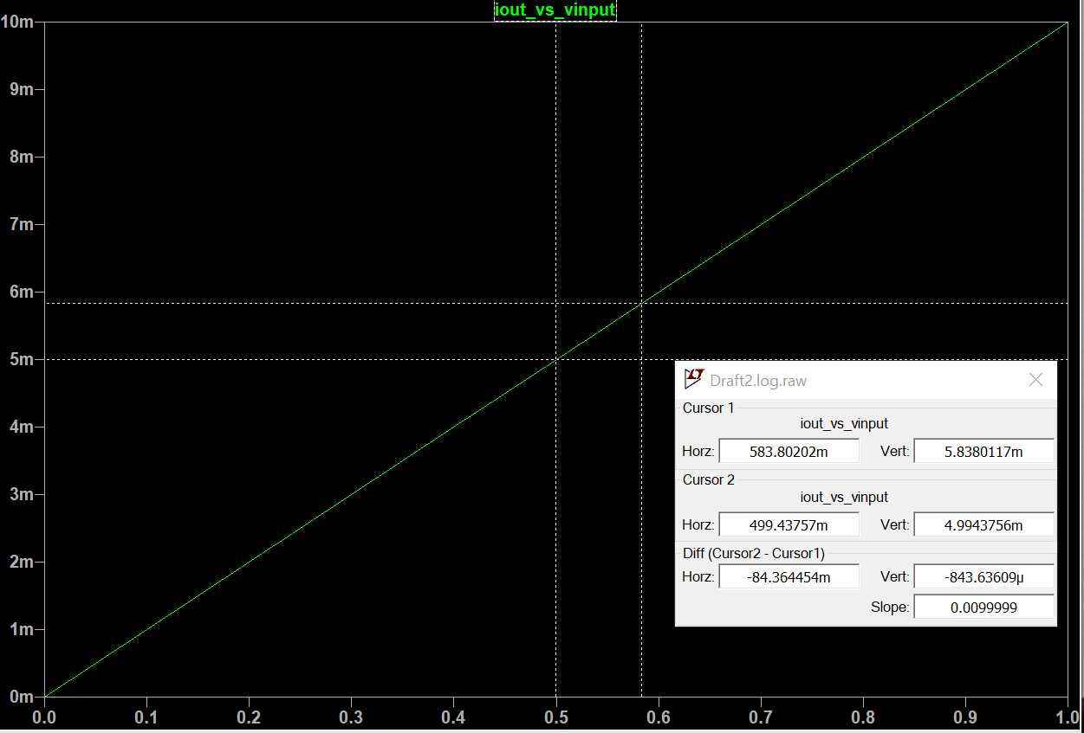

* 1. Change R1 to 10 Ω. Vary voltage Vi in the range of 0 – 100 mV D.C. with a step of 10 mV. Repeat the step-i.

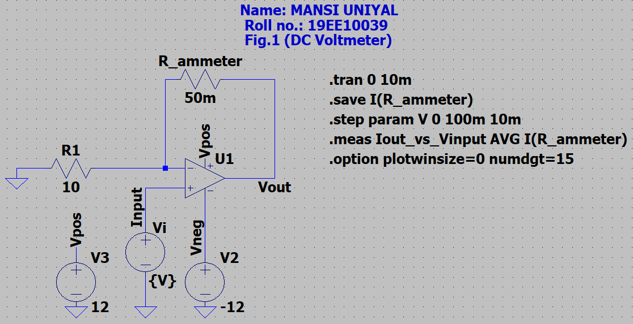

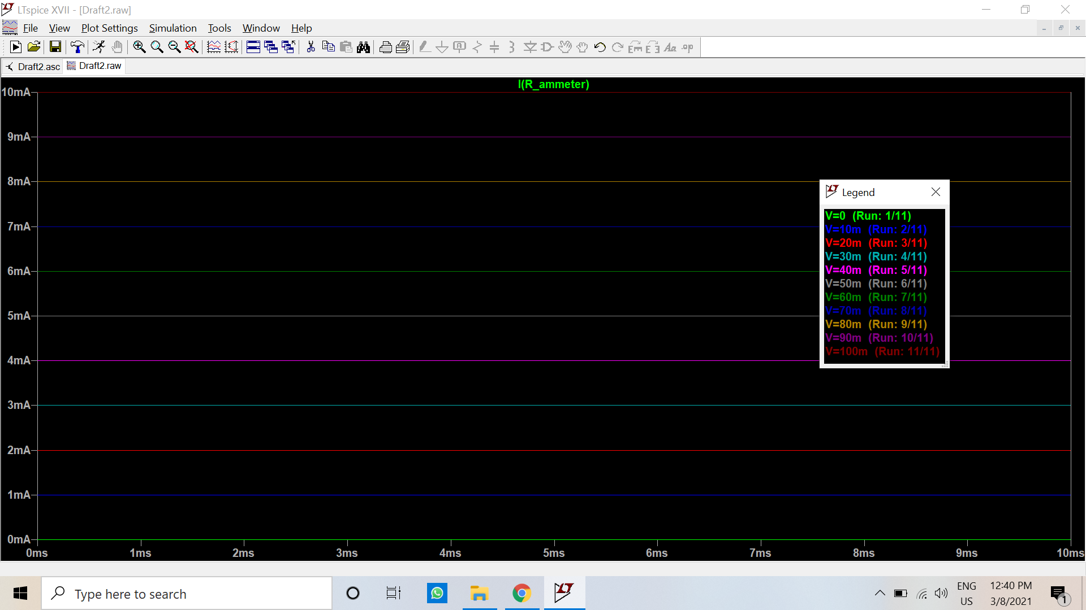

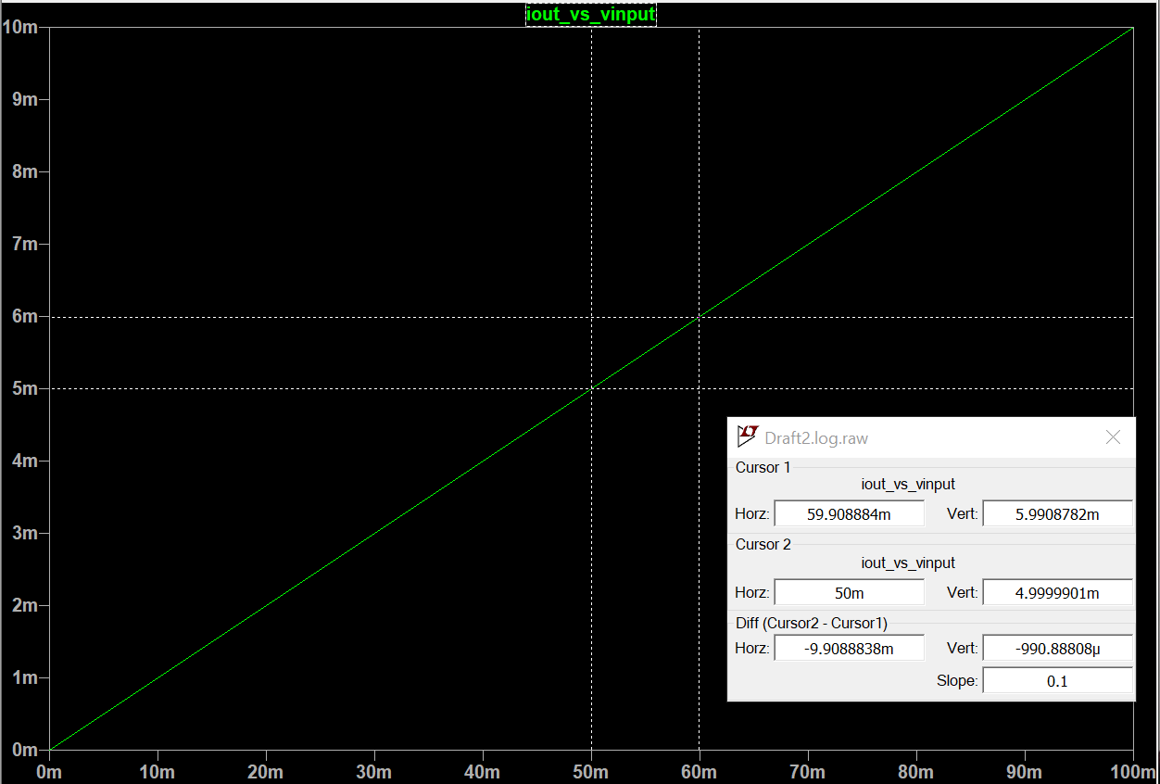

1. Draw neatly the above circuit shown in Fig. 3 in LTSpice. All the components should be chosen as ideal. Attach the screen-shot of the schematic.

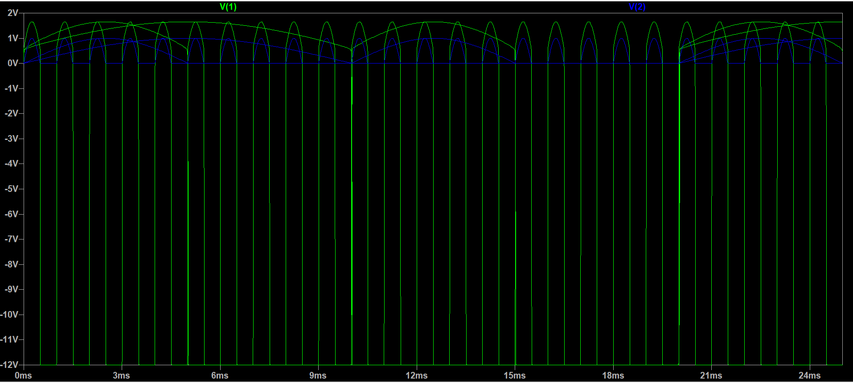

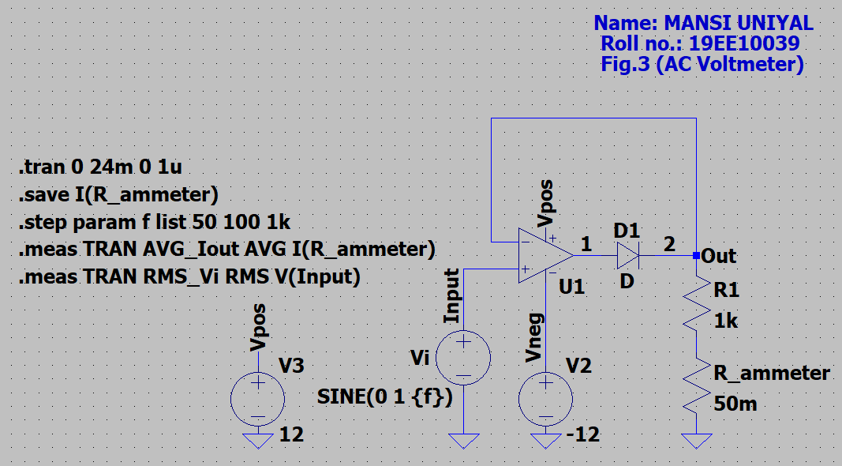

The milliammeter is replaced by an equivalent 50 mΩ resistance (Rammeter).

* + 1. Simulate the circuit for an A.C. sinusoidal input voltage Vi of 50 Hz frequency and peak value (Vm) of 1 V. Observe voltage waveforms at ‘Input’ and ‘Out’, and note whether the output is timely a halfwave rectified voltage or not. Attach the screenshot of voltage waveforms at ‘Input’ and ‘Out’.

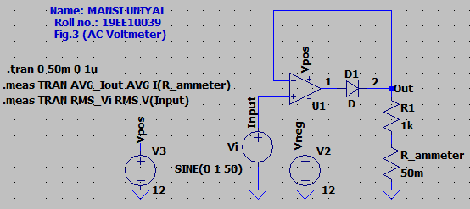

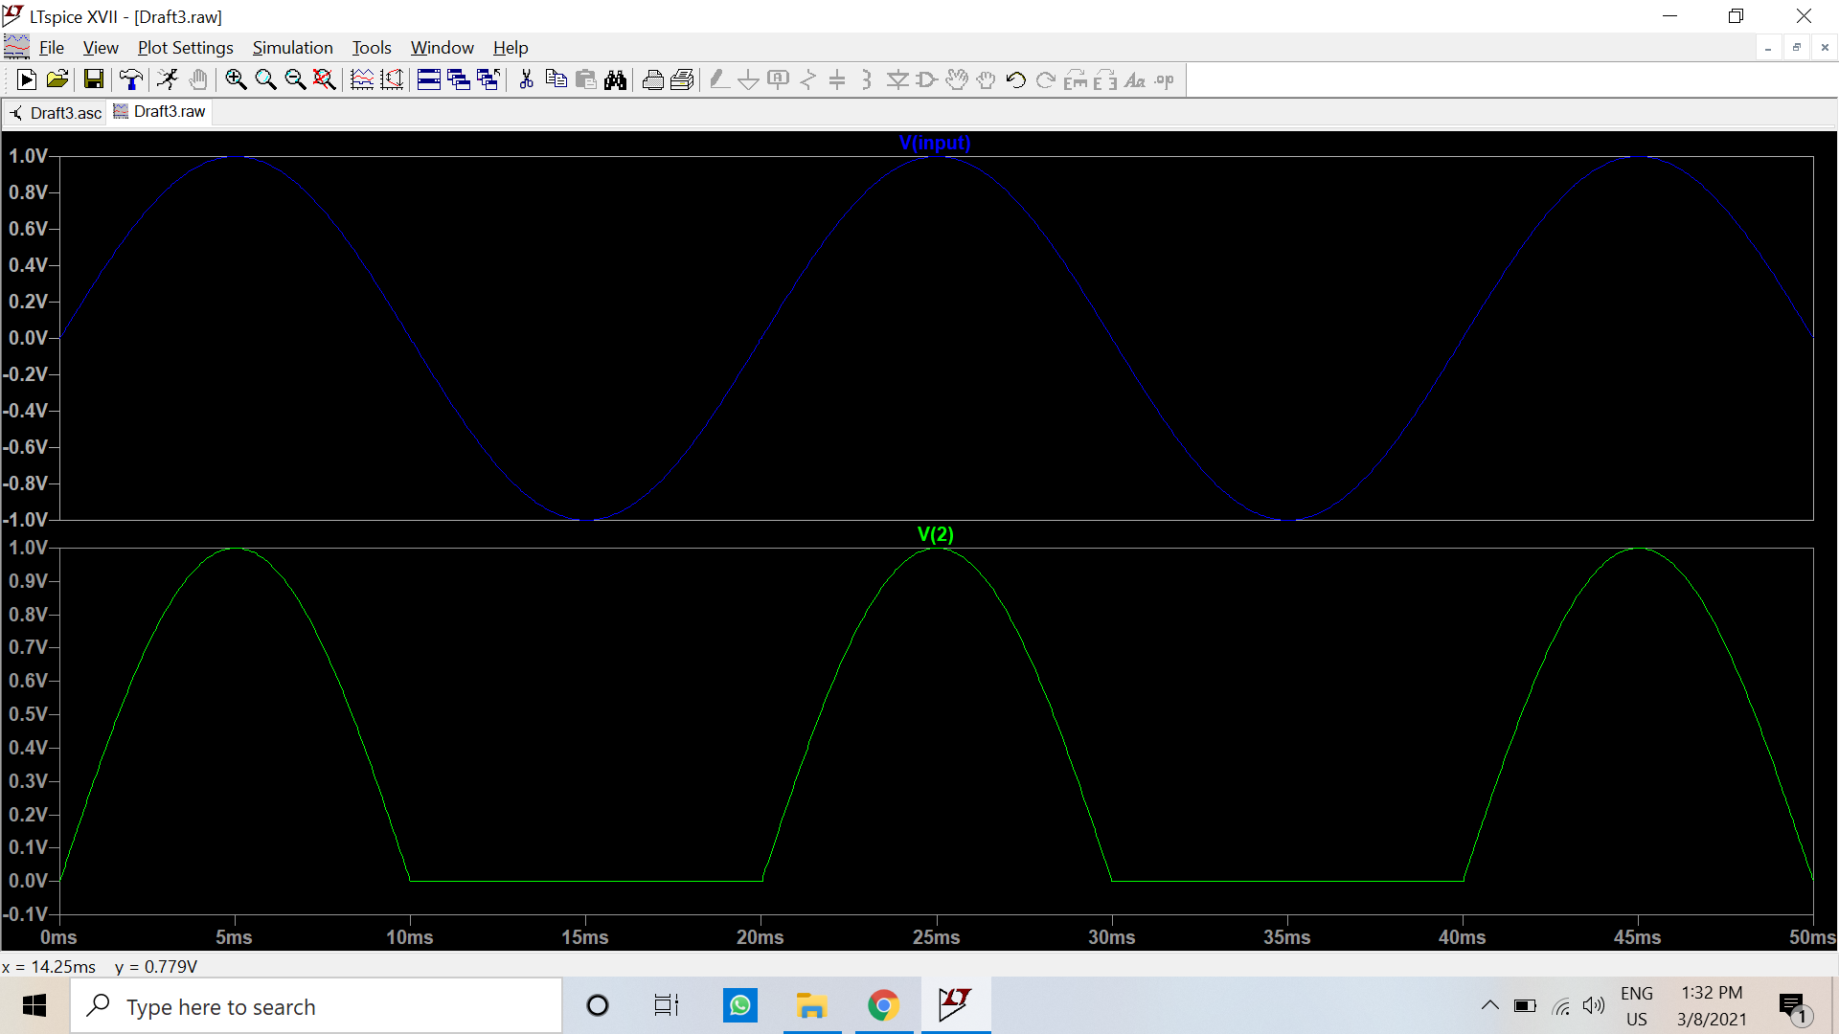

* + 1. Simulate the circuit for an A.C. sinusoidal input voltage Vi of 50 Hz frequency. Vary the peak value (Vm) of Vi in the range 0.1 V – 1 V with a step of 0.1 V. Attach the screenshot of the current I through the resistance Rammeter. Calculate the average current Iav using Eq.(1), and plot Iav vs. Vi.

Vrms = Vm/√2

$I_{av}=\frac{V_{rms} √2}{πR_{1}}$

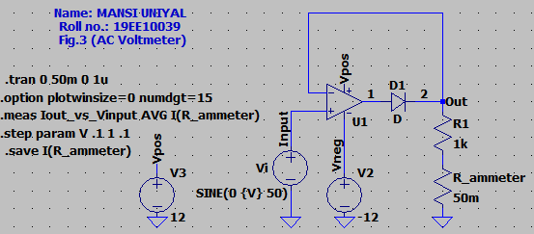

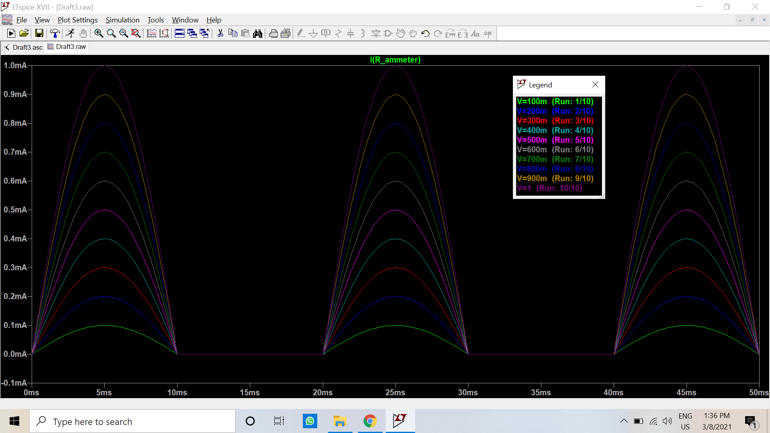

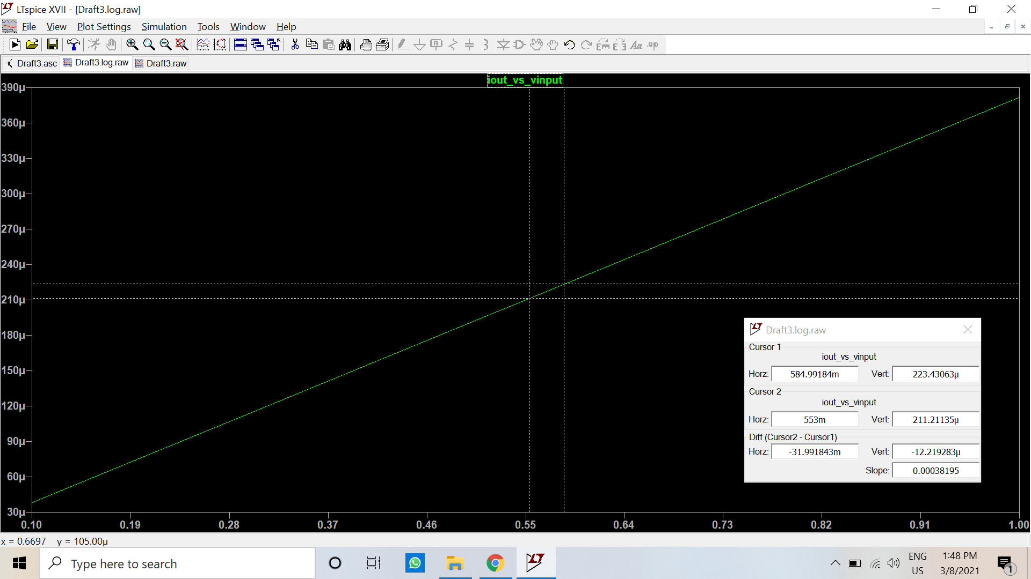

|  |  |  |  |  |
| --- | --- | --- | --- | --- |
| **Vi (V)** | **V_RMS (V)** | **I_AVG_calc (mA)** | **I_AVG_obs (mA)** | **% Error** |
| 0.1 | 0.0707 | 0.0318 | 0.0318 | 0 |
| 0.2 | 0.1414 | 0.0637 | 0.0635 | 0.31 |
| 0.3 | 0.2121 | 0.0955 | 0.0955 | 0 |
| 0.4 | 0.2828 | 0.1273 | 0.1273 | 0 |
| 0.5 | 0.3536 | 0.1592 | 0.1591 | 0.06 |
| 0.6 | 0.4243 | 0.191 | 0.191 | 0 |
| 0.7 | 0.495 | 0.2228 | 0.2228 | 0 |
| 0.8 | 0.5657 | 0.2547 | 0.2546 | 0.04 |
| 0.9 | 0.6364 | 0.2865 | 0.2864 | 0.03 |
| 1 | 0.7071 | 0.3183 | 0.3183 | 0 |

* + 1. Repeat step-i and step-ii for input frequencies of 100 Hz, and 1 kHz.

Frequency: 100Hz

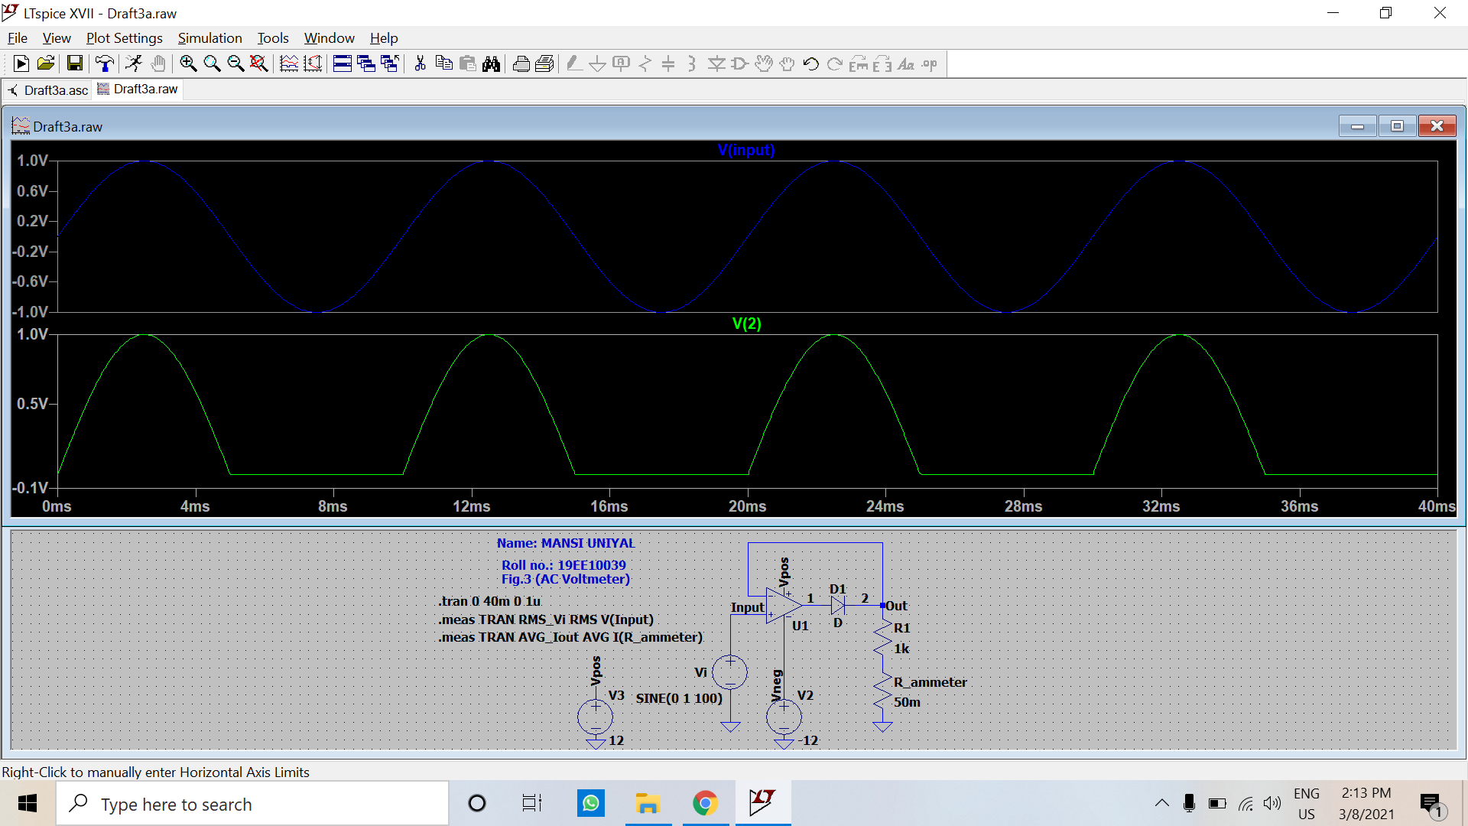

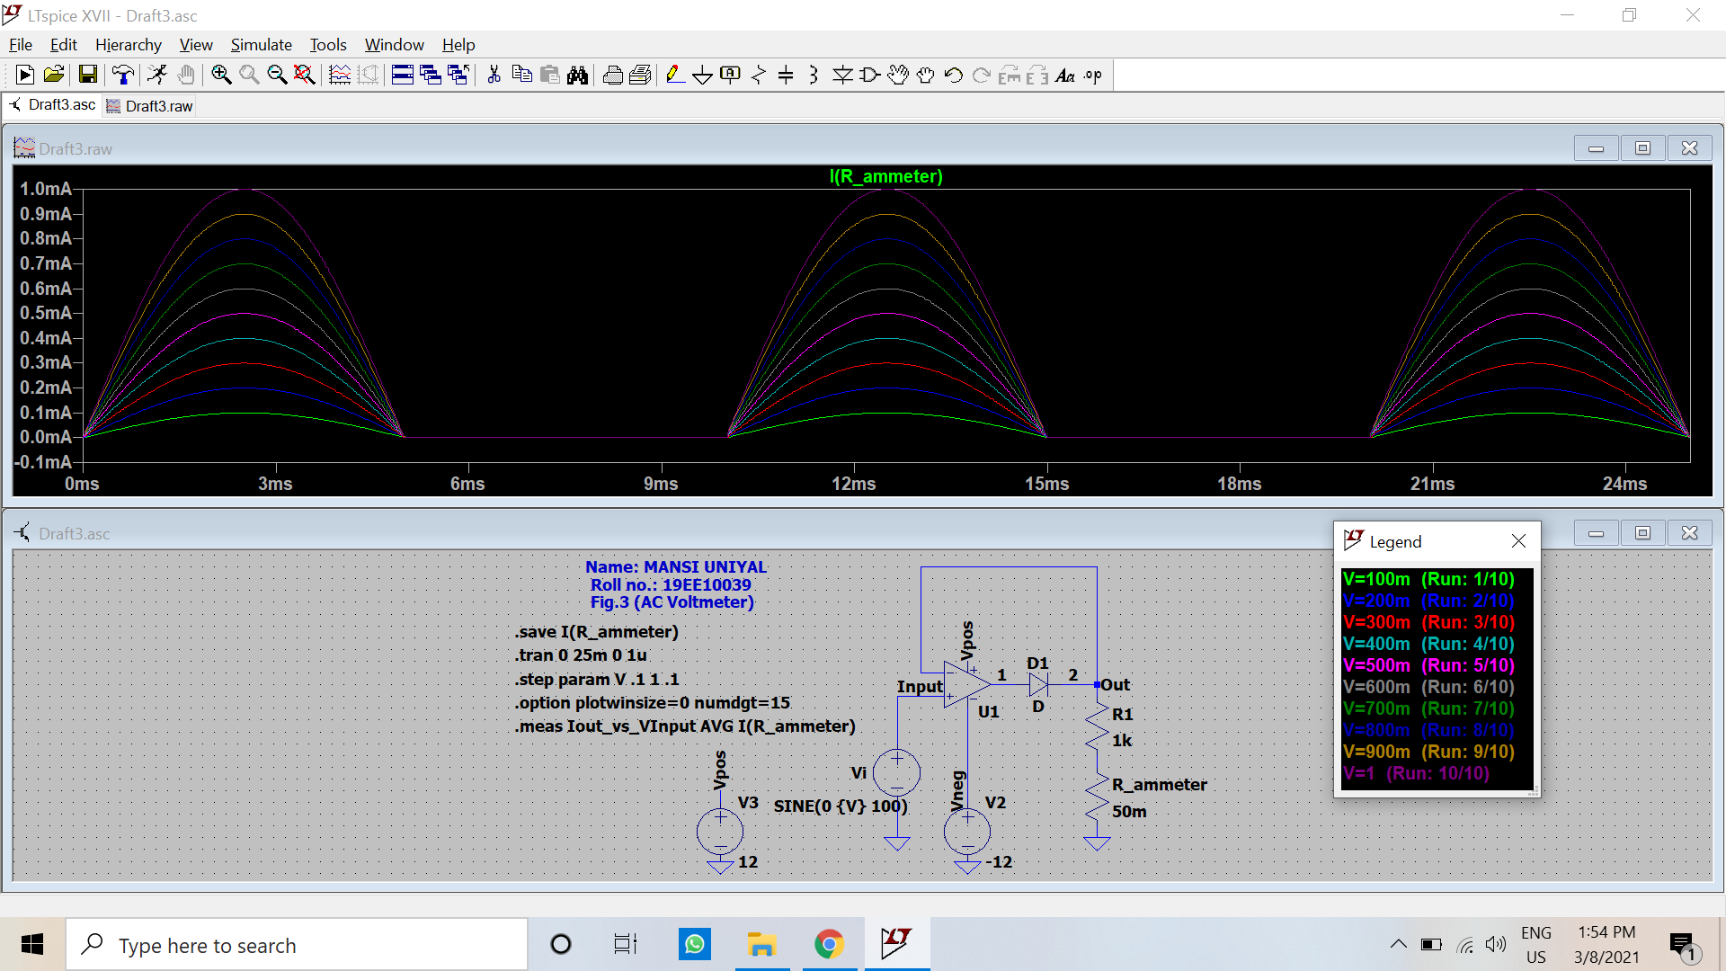

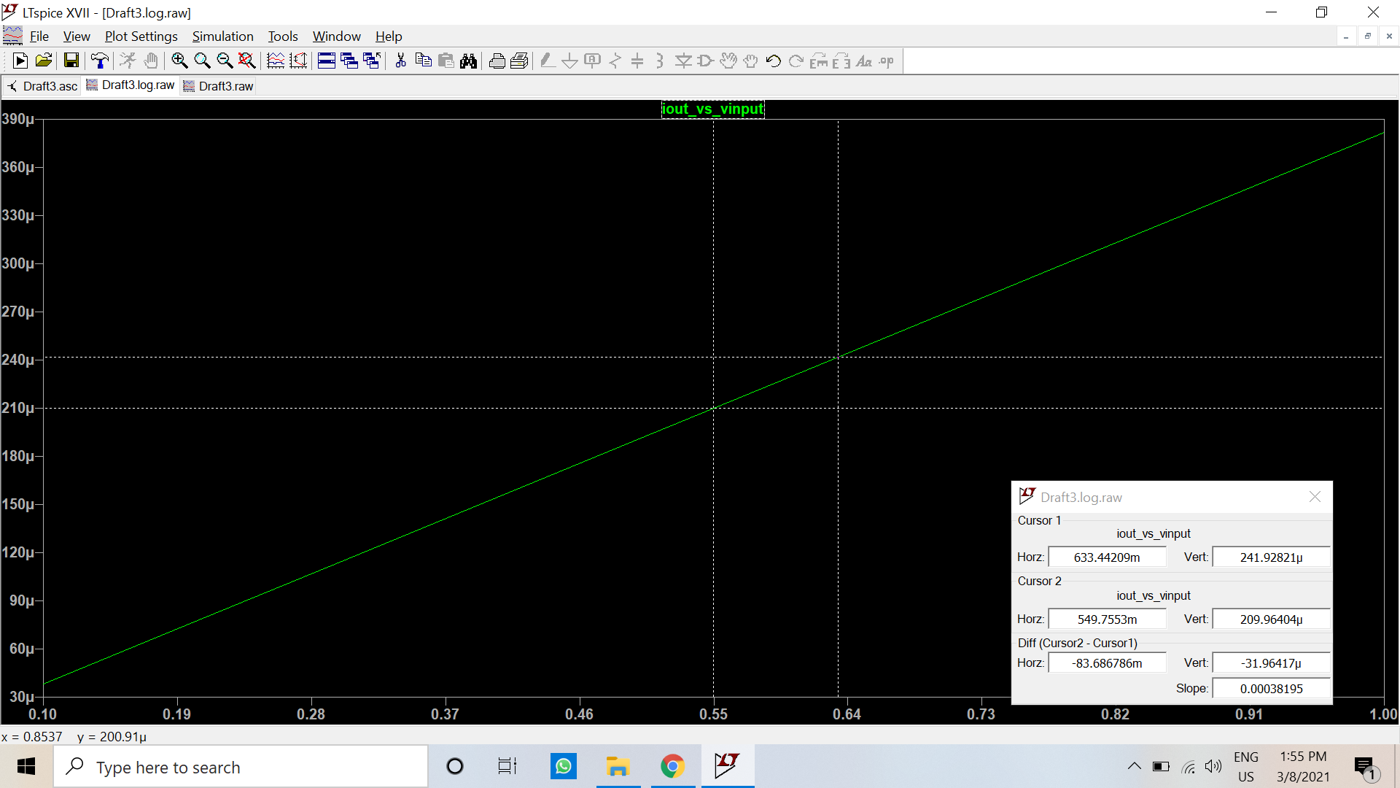

|  |  |  |  |  |
| --- | --- | --- | --- | --- |
| **Vi (V)** | **V_RMS (V)** | **I_AVG_calc (mA)** | **I_AVG_obs (mA)** | **% Error** |
| 0.1 | 0.0707 | 0.0318 | 0.0318 | 0 |
| 0.2 | 0.1414 | 0.0637 | 0.0636 | 0.16 |
| 0.3 | 0.2121 | 0.0955 | 0.0955 | 0 |
| 0.4 | 0.2828 | 0.1273 | 0.1273 | 0 |
| 0.5 | 0.3536 | 0.1592 | 0.1591 | 0.06 |
| 0.6 | 0.4243 | 0.191 | 0.191 | 0 |
| 0.7 | 0.495 | 0.2228 | 0.2228 | 0 |
| 0.8 | 0.5657 | 0.2547 | 0.2546 | 0.04 |
| 0.9 | 0.6364 | 0.2865 | 0.2864 | 0.03 |
| 1 | 0.7071 | 0.3183 | 0.3183 | 0 |

Frequency: 1000Hz

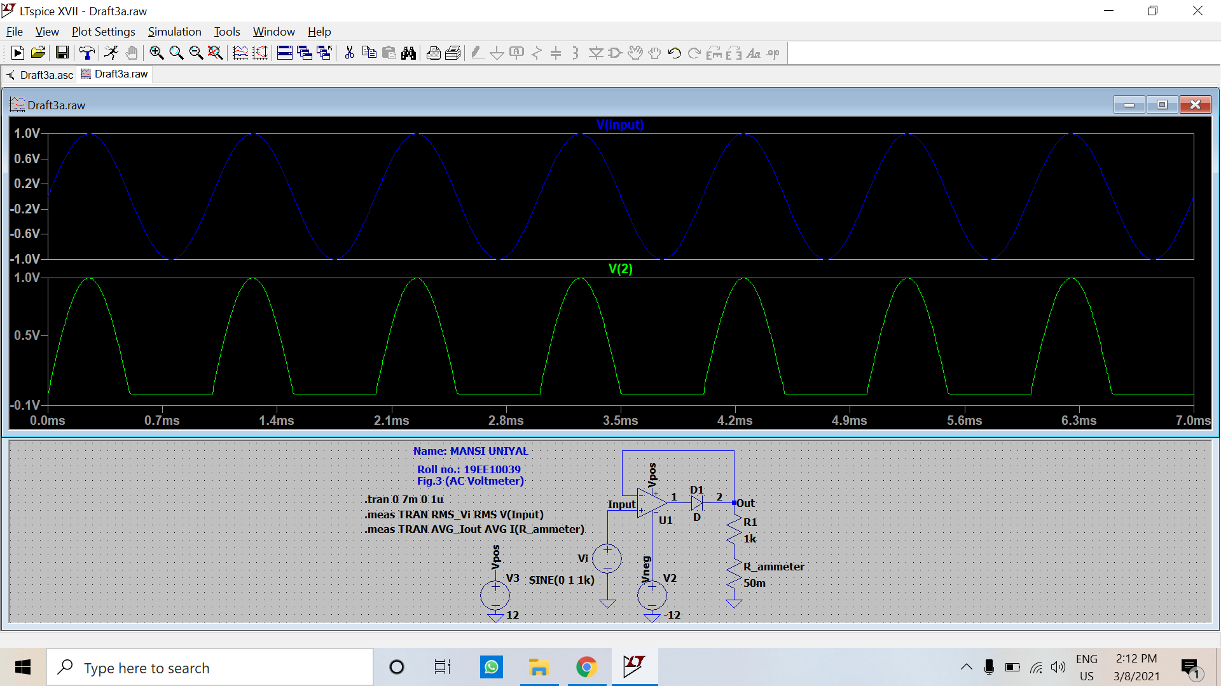

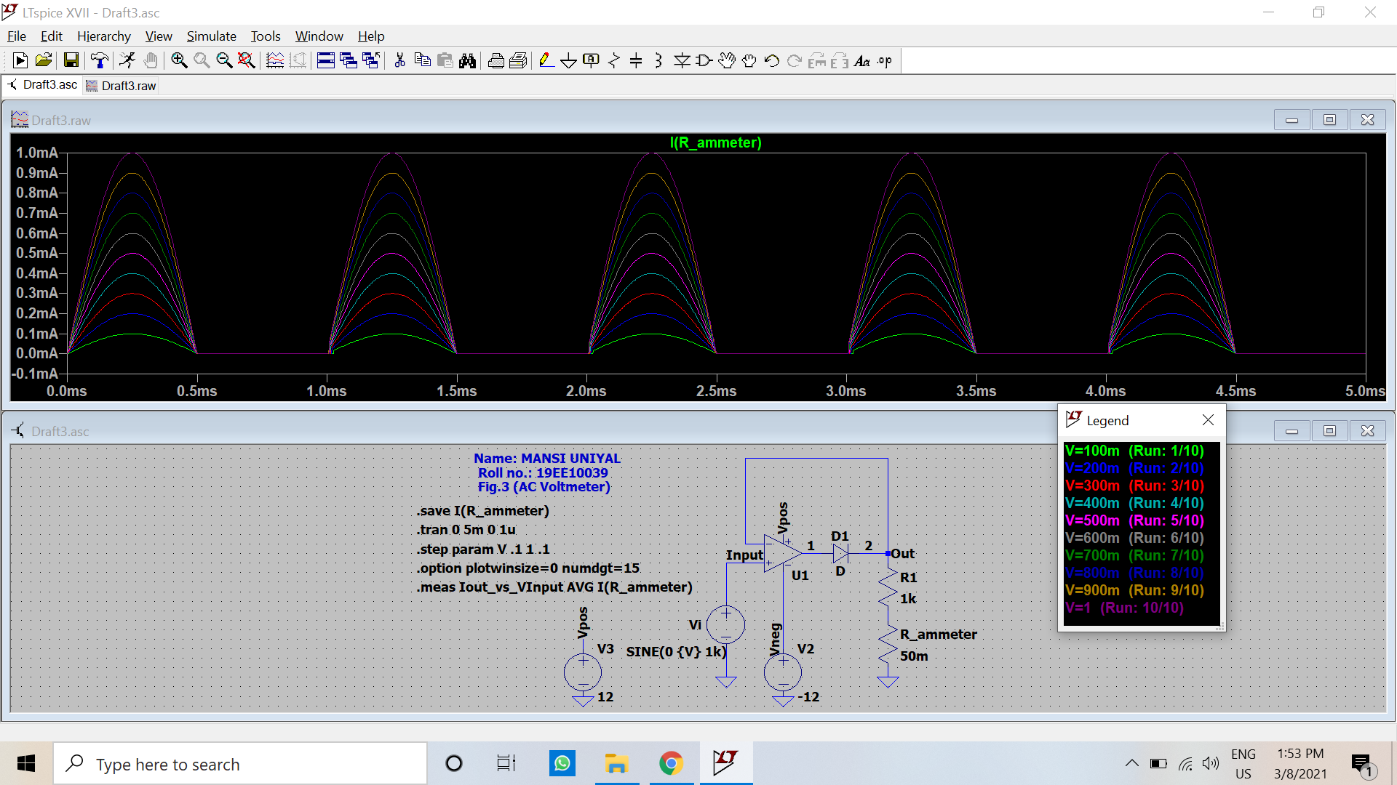

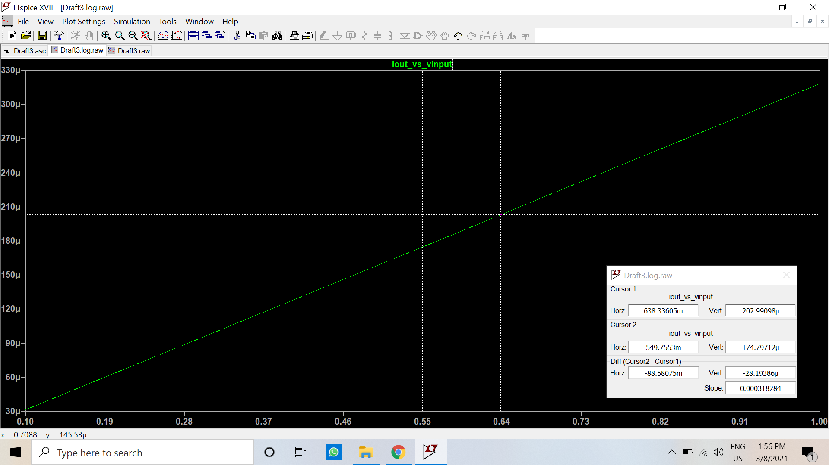

|  |  |  |  |  |
| --- | --- | --- | --- | --- |
| **Vi (V)** | **V_RMS (V)** | **I_AVG_calc (mA)** | **I_AVG_obs (mA)** | **% Error** |
| 0.1 | 0.0707 | 0.0318 | 0.0317 | 0.31 |
| 0.2 | 0.1414 | 0.0637 | 0.0636 | 0.16 |
| 0.3 | 0.2121 | 0.0955 | 0.0954 | 0.1 |
| 0.4 | 0.2828 | 0.1273 | 0.1272 | 0.08 |
| 0.5 | 0.3536 | 0.1592 | 0.159 | 0.13 |
| 0.6 | 0.4243 | 0.191 | 0.1909 | 0.05 |
| 0.7 | 0.495 | 0.2228 | 0.2227 | 0.04 |
| 0.8 | 0.5657 | 0.2547 | 0.2545 | 0.08 |
| 0.9 | 0.6364 | 0.2865 | 0.2864 | 0.03 |
| 1 | 0.7071 | 0.3183 | 0.3182 | 0.03 |

1. Draw neatly the above circuit shown in Fig. 4 in LTSpice. All the components should be chosen as ideal. Attach the screen-shot of the schematic.

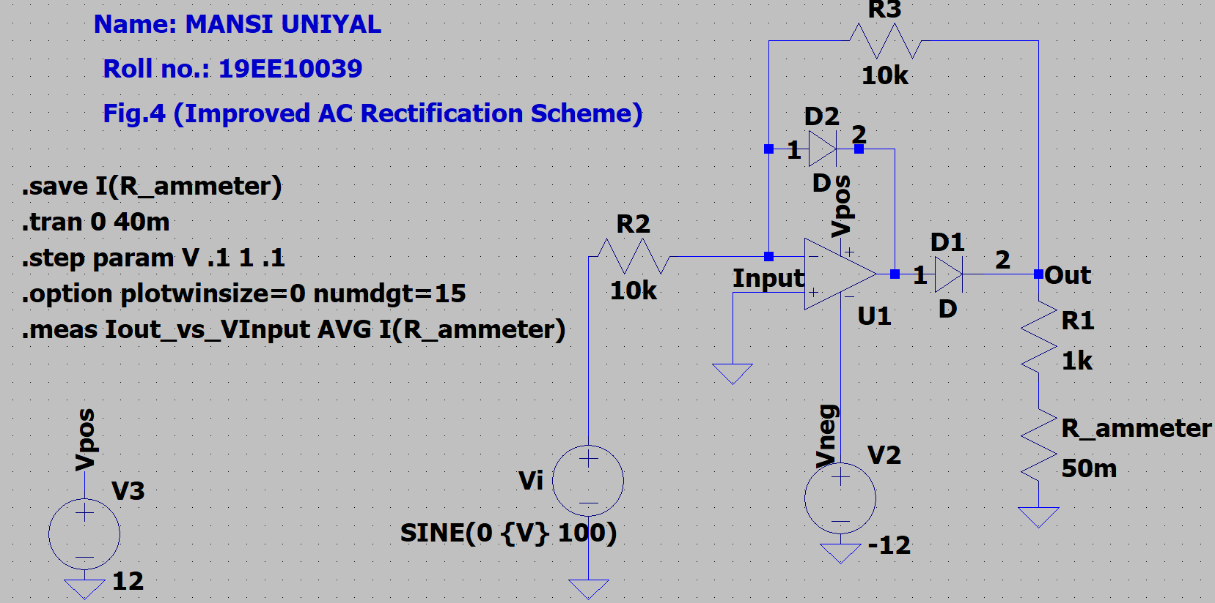

The milliammeter is replaced by an equivalent 50 mΩ resistance (Rammeter).

* 1. Repeat steps i – iii of part 3 and observe the improvement.

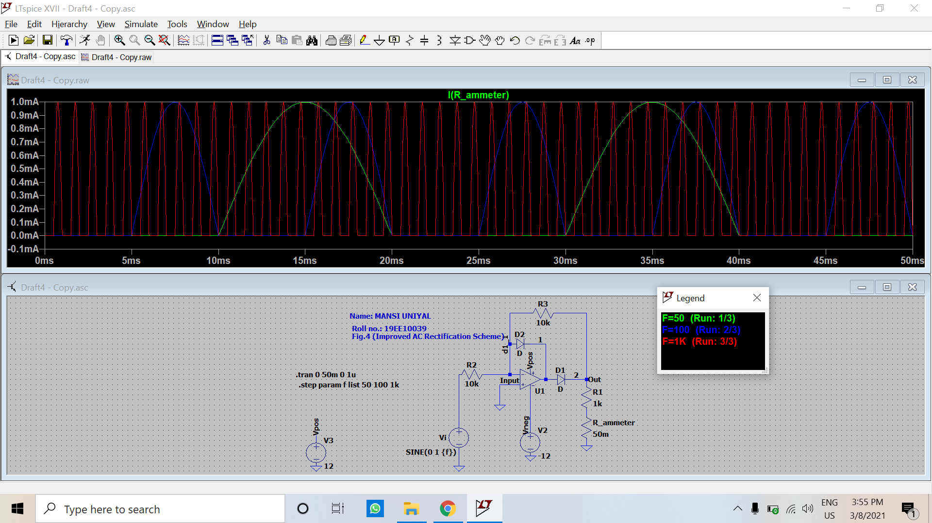

Frequency: 50Hz

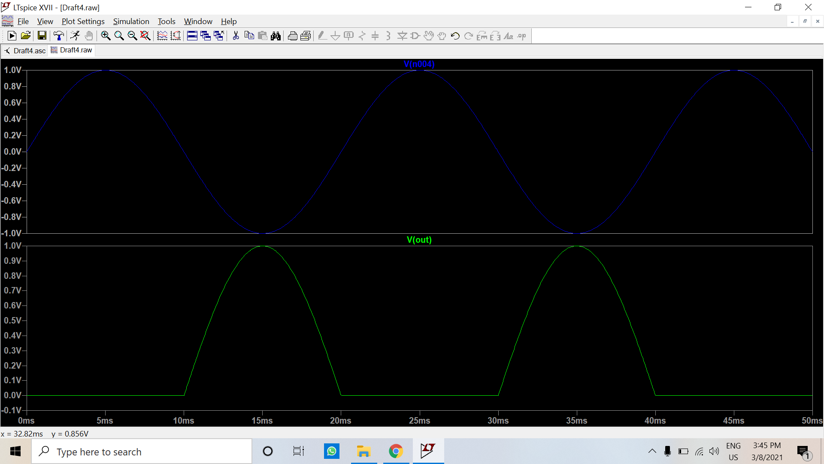

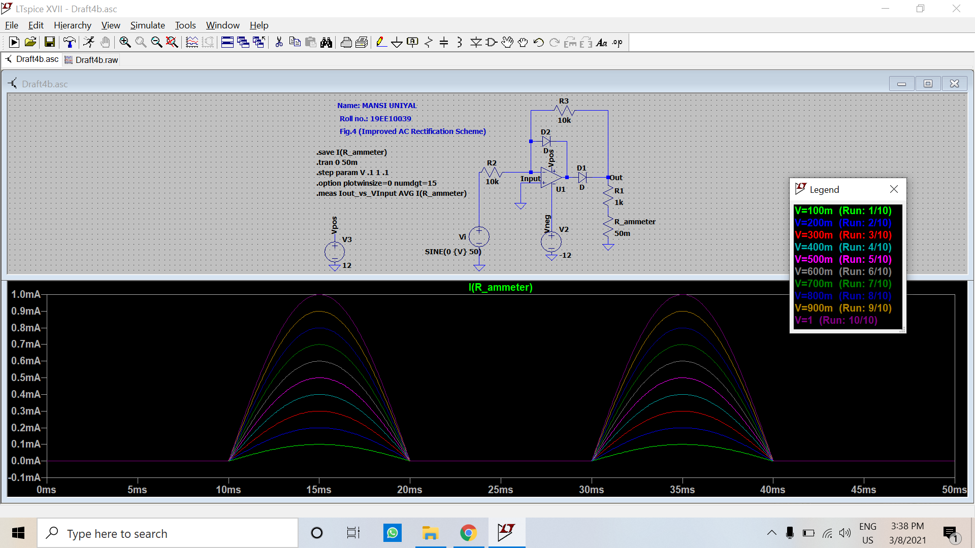

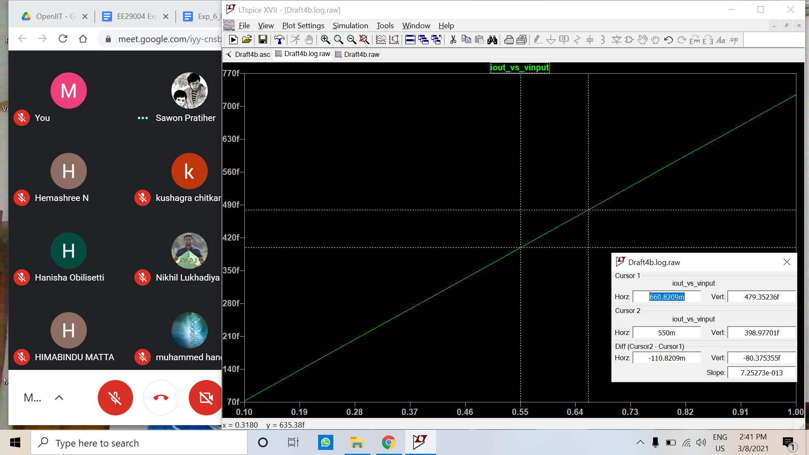

|  |  |  |  |  |
| --- | --- | --- | --- | --- |
| **Vi (V)** | **V_RMS (V)** | **I_AVG_calc (mA)** | **I_AVG_obs (mA)** | **% Error** |
| 0.1 | 0.0707 | 0.0318 | 0.0318 | 0 |
| 0.2 | 0.1414 | 0.0637 | 0.0635 | 0.31 |
| 0.3 | 0.2121 | 0.0955 | 0.0955 | 0 |
| 0.4 | 0.2828 | 0.1273 | 0.1273 | 0 |
| 0.5 | 0.3536 | 0.1592 | 0.1591 | 0.06 |
| 0.6 | 0.4243 | 0.191 | 0.191 | 0 |
| 0.7 | 0.495 | 0.2228 | 0.2228 | 0 |
| 0.8 | 0.5657 | 0.2547 | 0.2546 | 0.04 |
| 0.9 | 0.6364 | 0.2865 | 0.2864 | 0.03 |
| 1 | 0.7071 | 0.3183 | 0.3183 | 0 |

Frequency: 100Hz

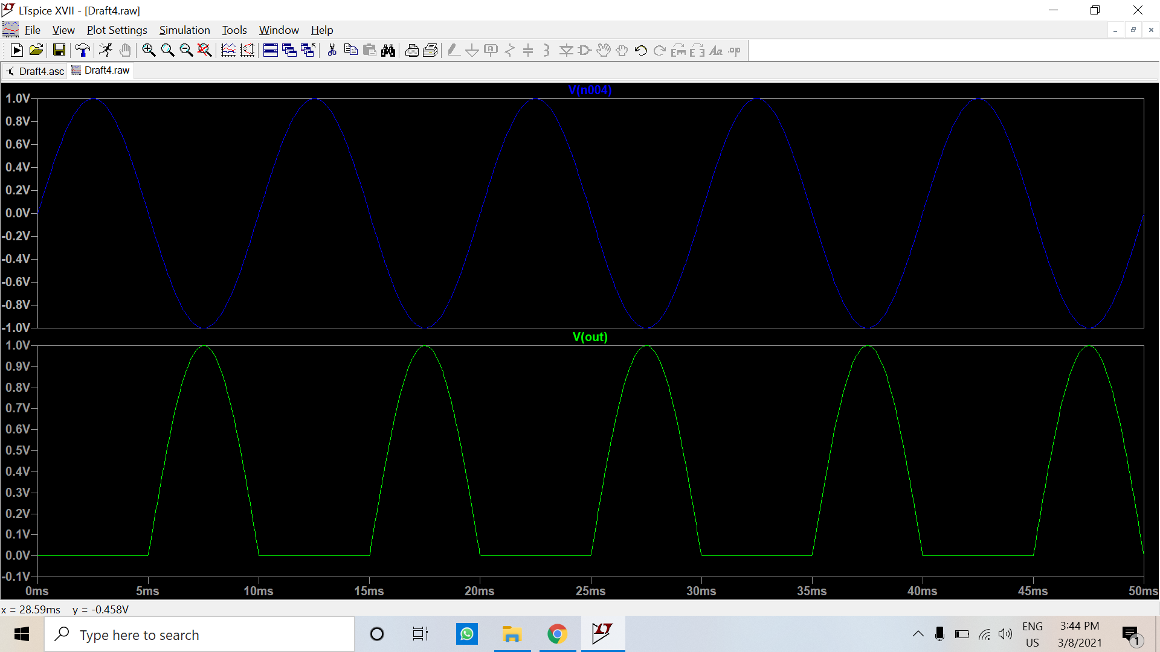

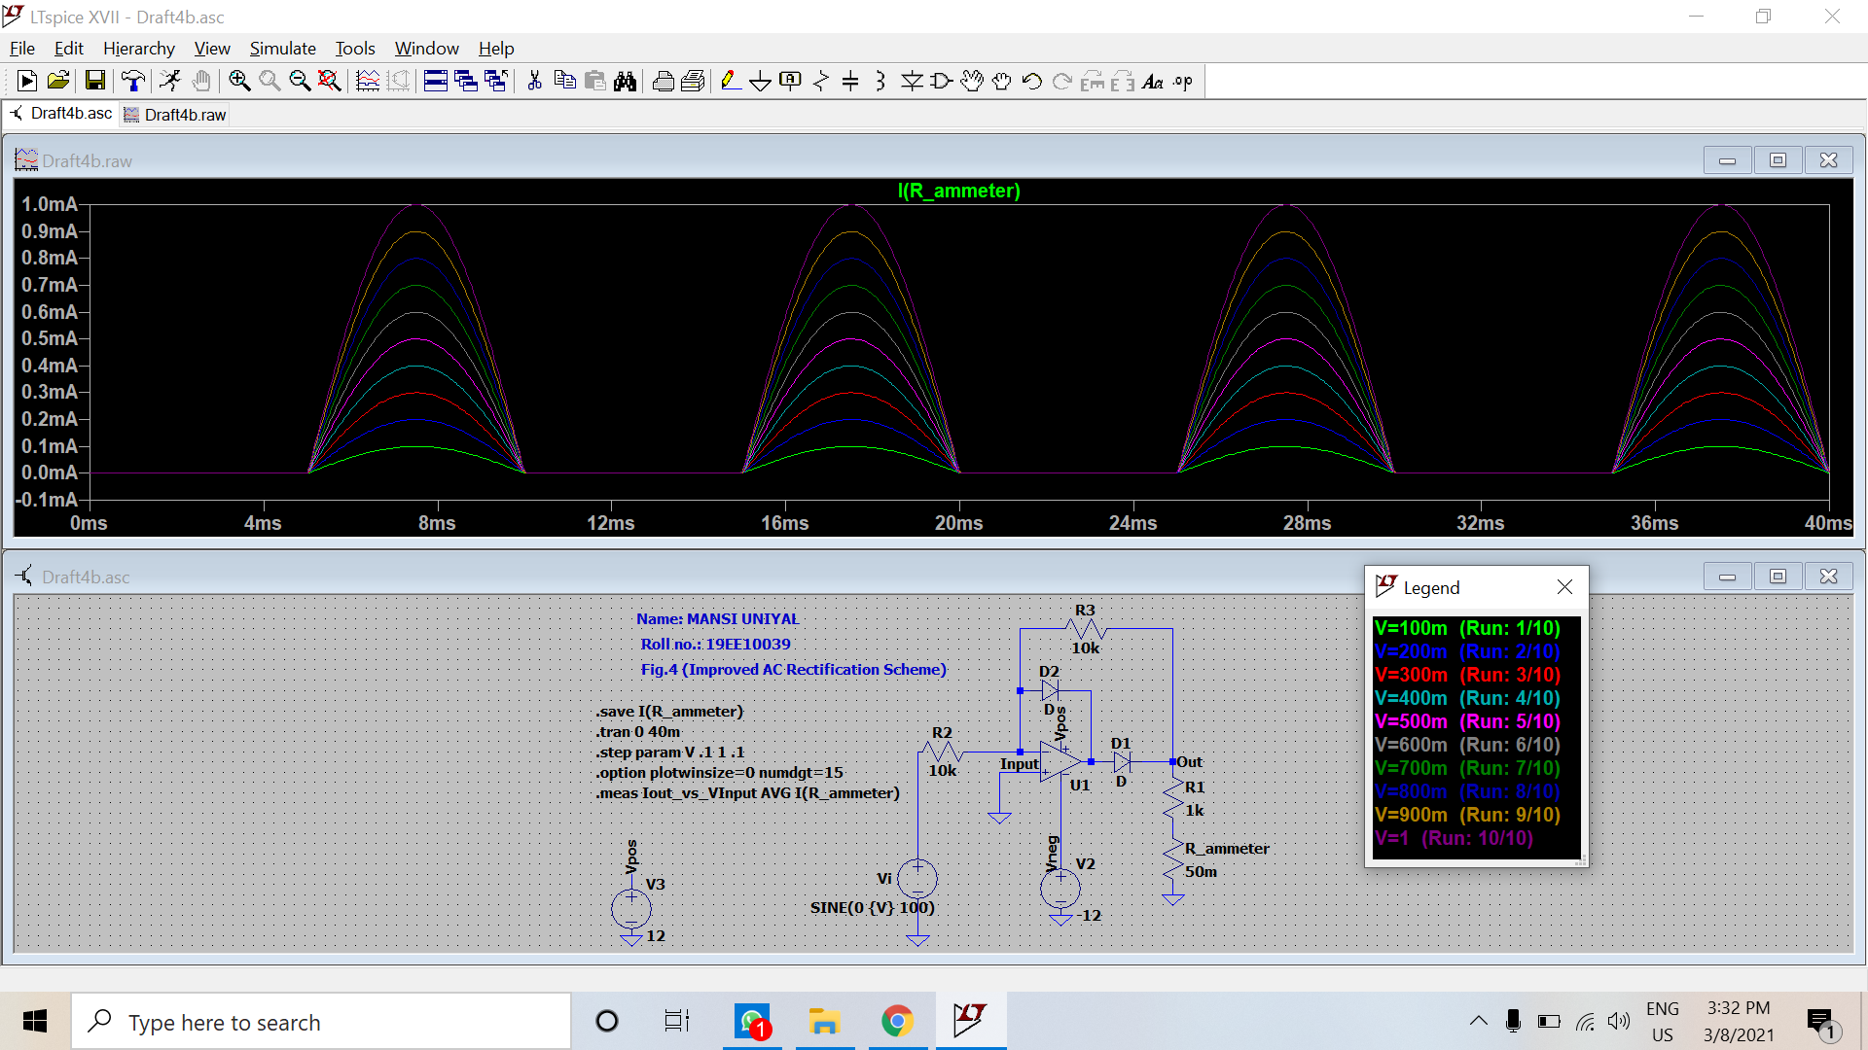

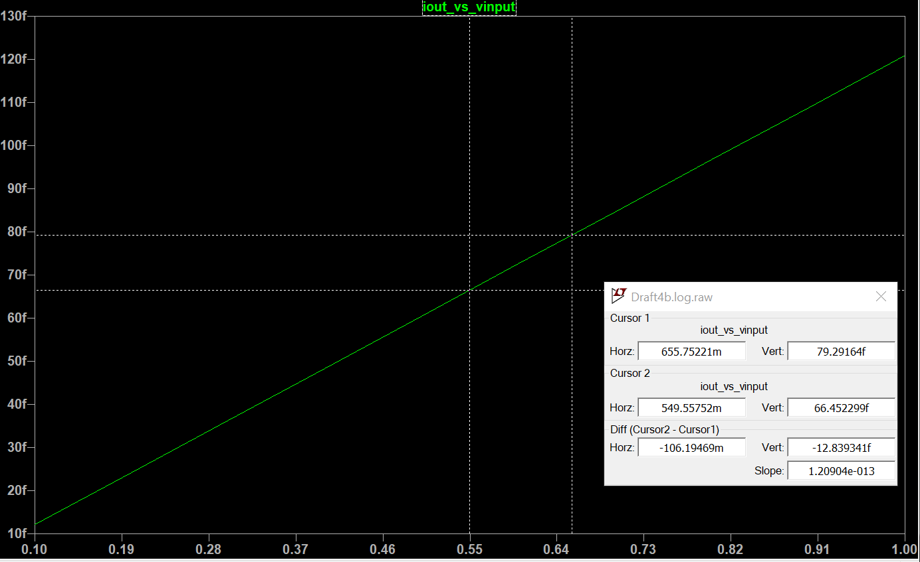

|  |  |  |  |  |
| --- | --- | --- | --- | --- |
| **Vi (V)** | **V_RMS (V)** | **I_AVG_calc (mA)** | **I_AVG_obs (mA)** | **% Error** |
| 0.1 | 0.0707 | 0.0318 | 0.0318 | 0 |
| 0.2 | 0.1414 | 0.0637 | 0.0636 | 0.16 |
| 0.3 | 0.2121 | 0.0955 | 0.0955 | 0 |
| 0.4 | 0.2828 | 0.1273 | 0.1273 | 0 |
| 0.5 | 0.3536 | 0.1592 | 0.1591 | 0.06 |
| 0.6 | 0.4243 | 0.191 | 0.191 | 0 |
| 0.7 | 0.495 | 0.2228 | 0.2228 | 0 |
| 0.8 | 0.5657 | 0.2547 | 0.2546 | 0.04 |
| 0.9 | 0.6364 | 0.2865 | 0.2864 | 0.03 |
| 1 | 0.7071 | 0.3183 | 0.3183 | 0 |

Frequency: 1000Hz

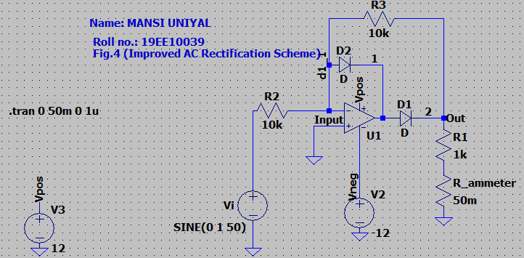

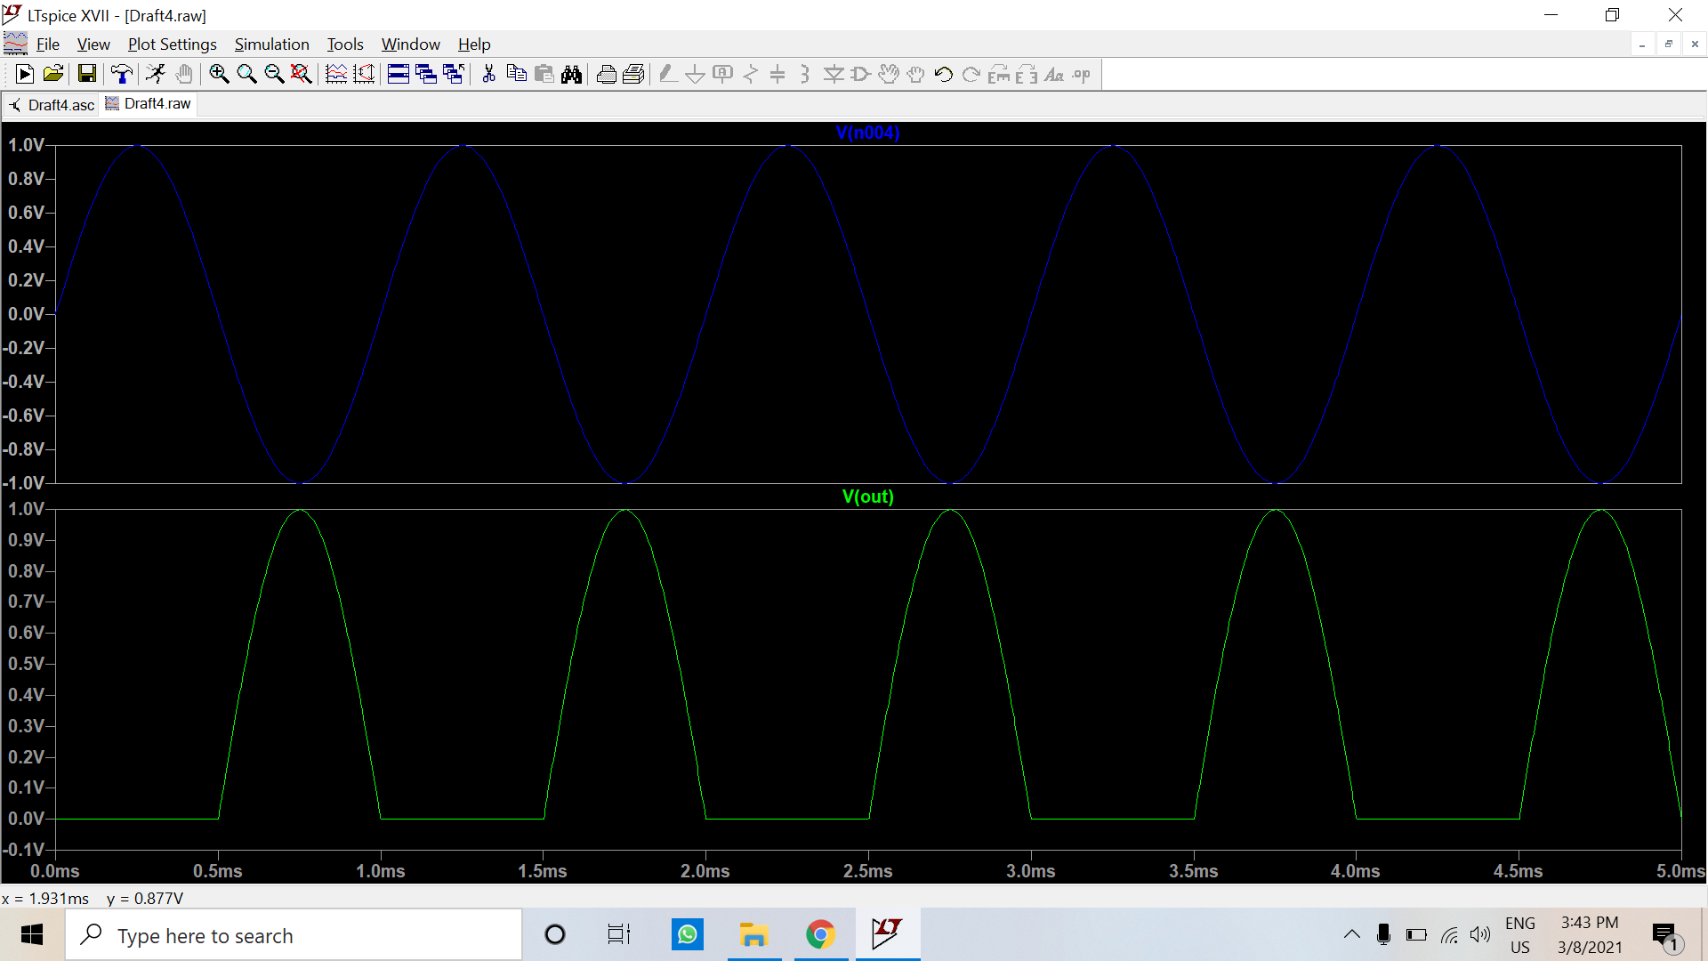

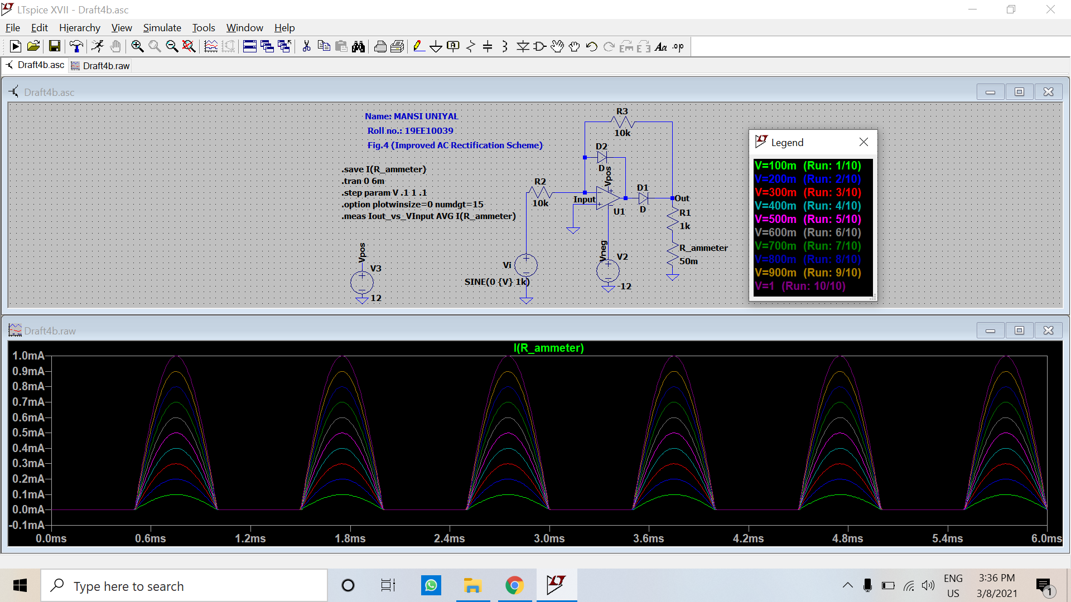

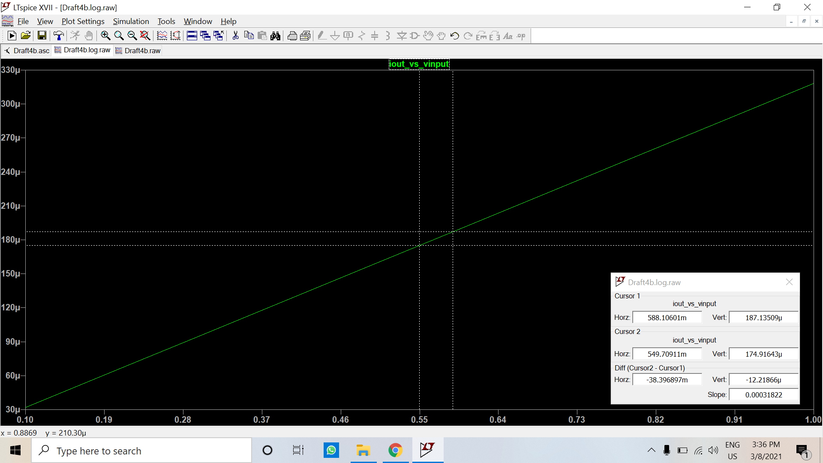

|  |  |  |  |  |
| --- | --- | --- | --- | --- |
| **Vi (V)** | **V_RMS (V)** | **I_AVG_calc (mA)** | **I_AVG_obs (mA)** | **% Error** |
| 0.1 | 0.0707 | 0.0318 | 0.0318 | 0 |
| 0.2 | 0.1414 | 0.0637 | 0.0636 | 0.16 |
| 0.3 | 0.2121 | 0.0955 | 0.0954 | 0.1 |
| 0.4 | 0.2828 | 0.1273 | 0.1273 | 0 |
| 0.5 | 0.3536 | 0.1592 | 0.1591 | 0.06 |
| 0.6 | 0.4243 | 0.191 | 0.191 | 0 |
| 0.7 | 0.495 | 0.2228 | 0.2228 | 0 |
| 0.8 | 0.5657 | 0.2547 | 0.2546 | 0.04 |
| 0.9 | 0.6364 | 0.2865 | 0.2864 | 0.03 |
| 1 | 0.7071 | 0.3183 | 0.3183 | 0 |

Discussions:

1. Briefly discuss the working of the circuit in Fig. 4.

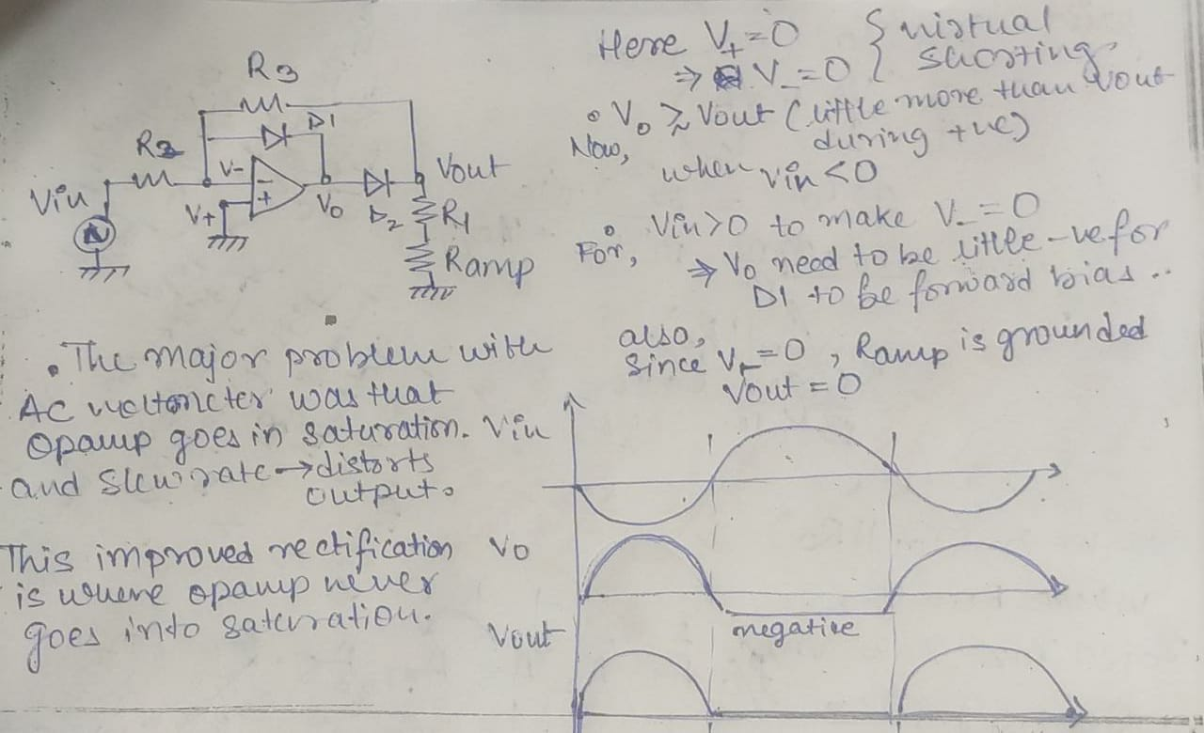

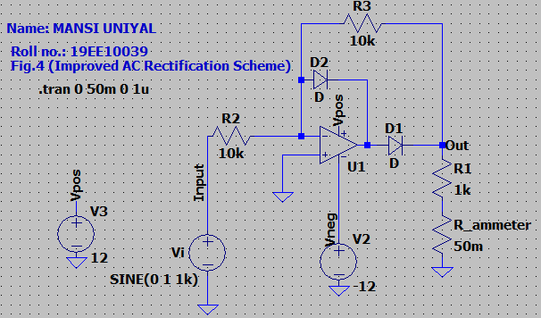

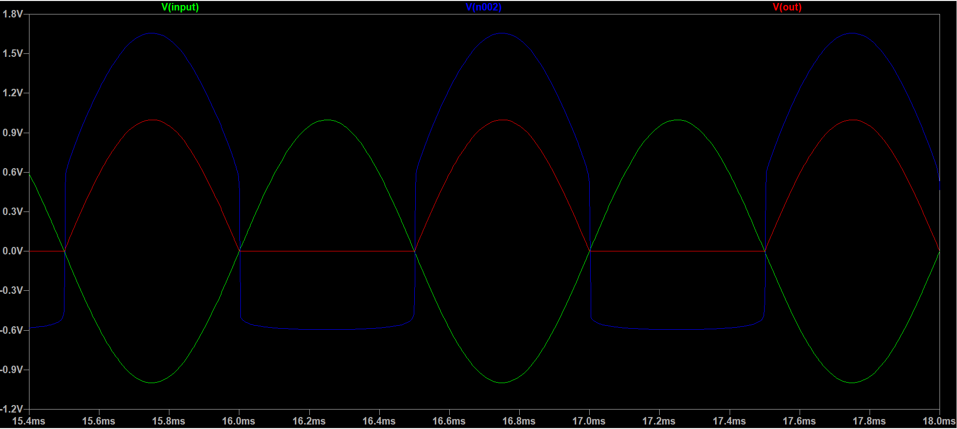

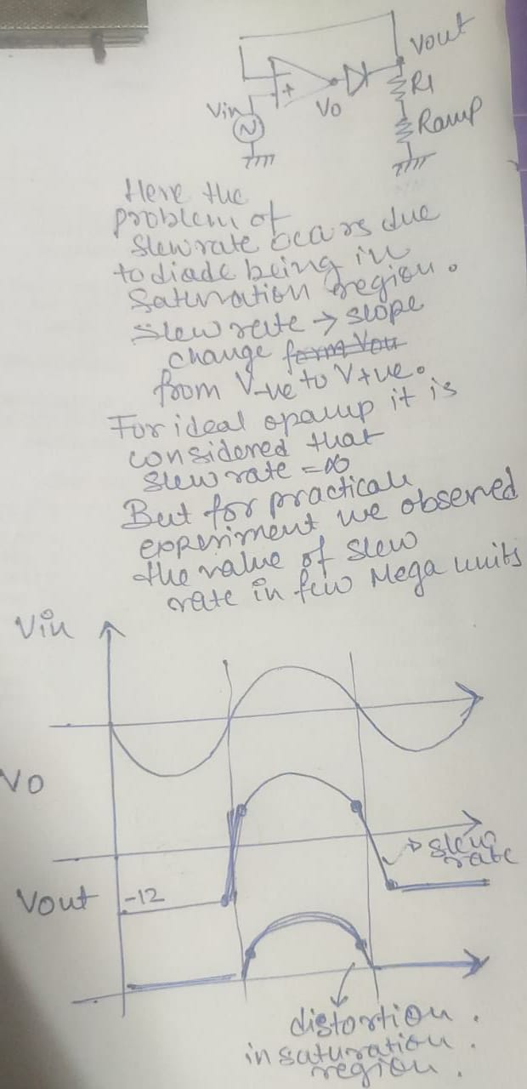

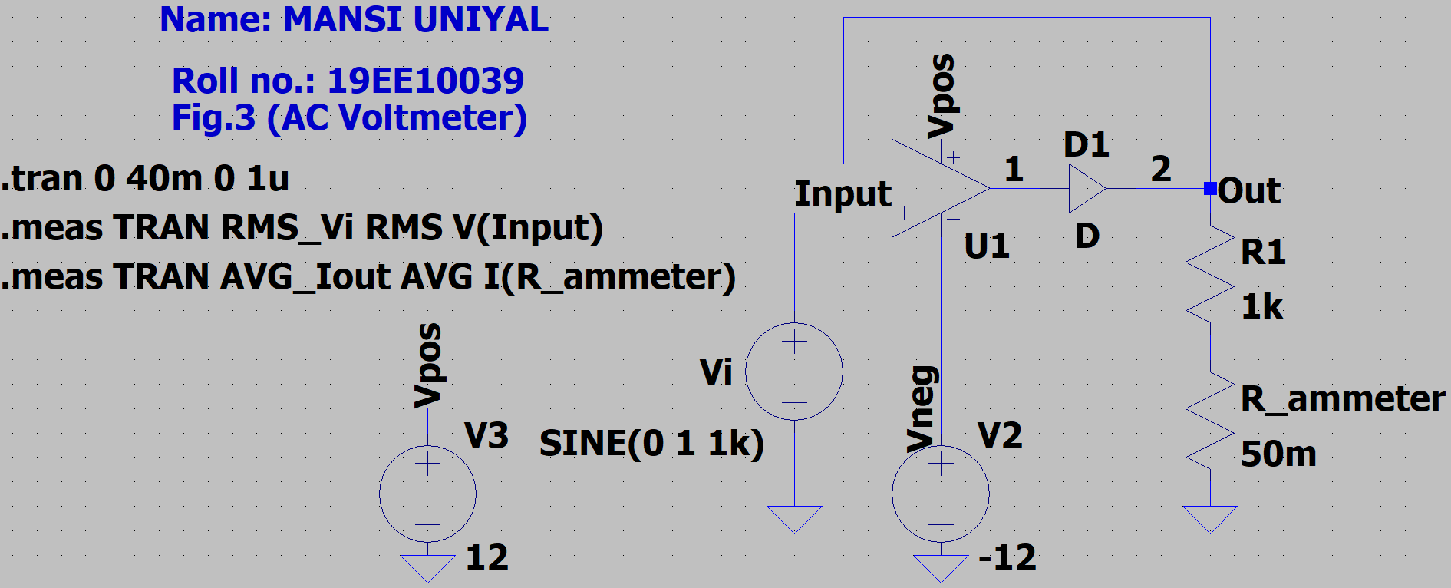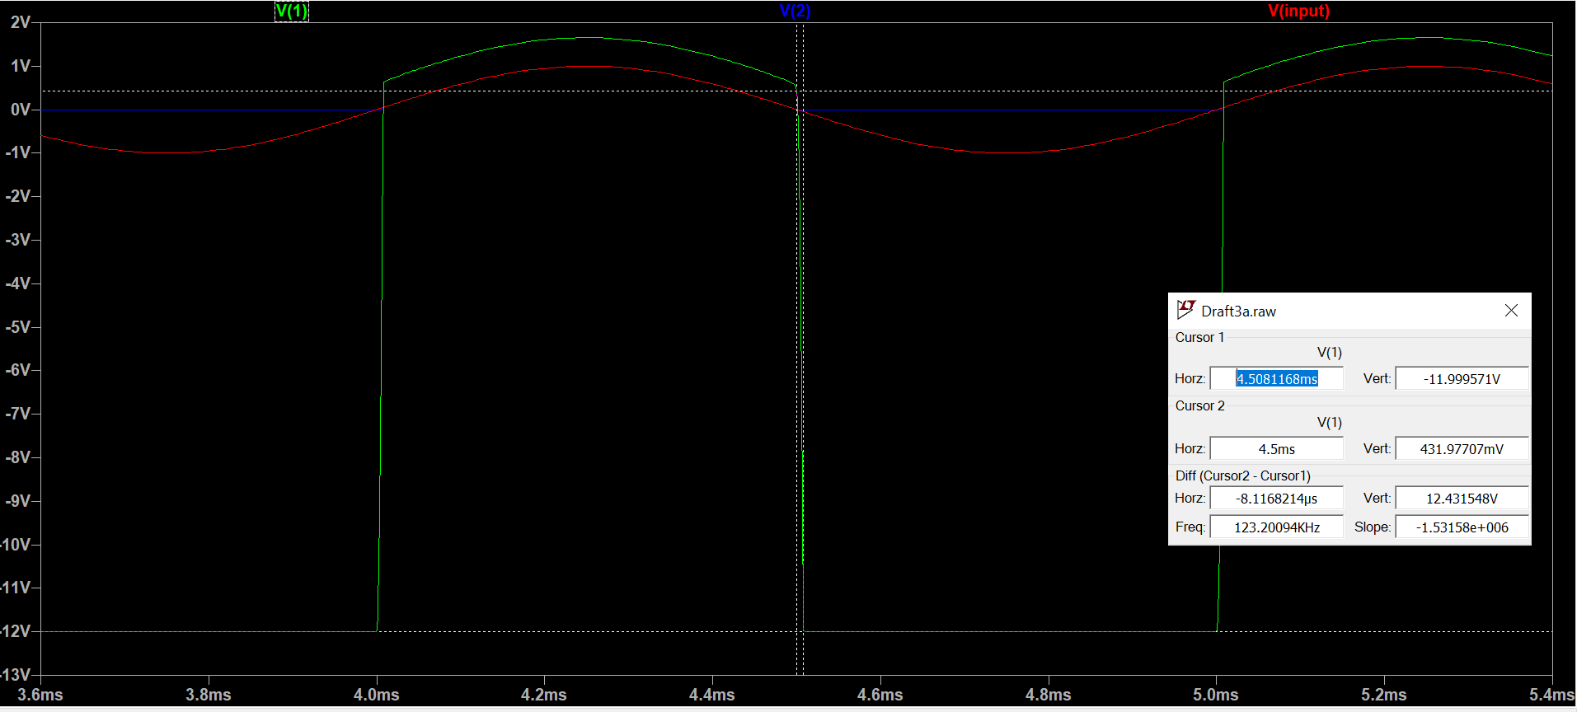

**Note**: Choose the ‘UniversalOpamp2’ in LTSpice while designing the circuit.